**Naincy Thapa**

**IT 520- Lab 5**

**March 25, 2019**

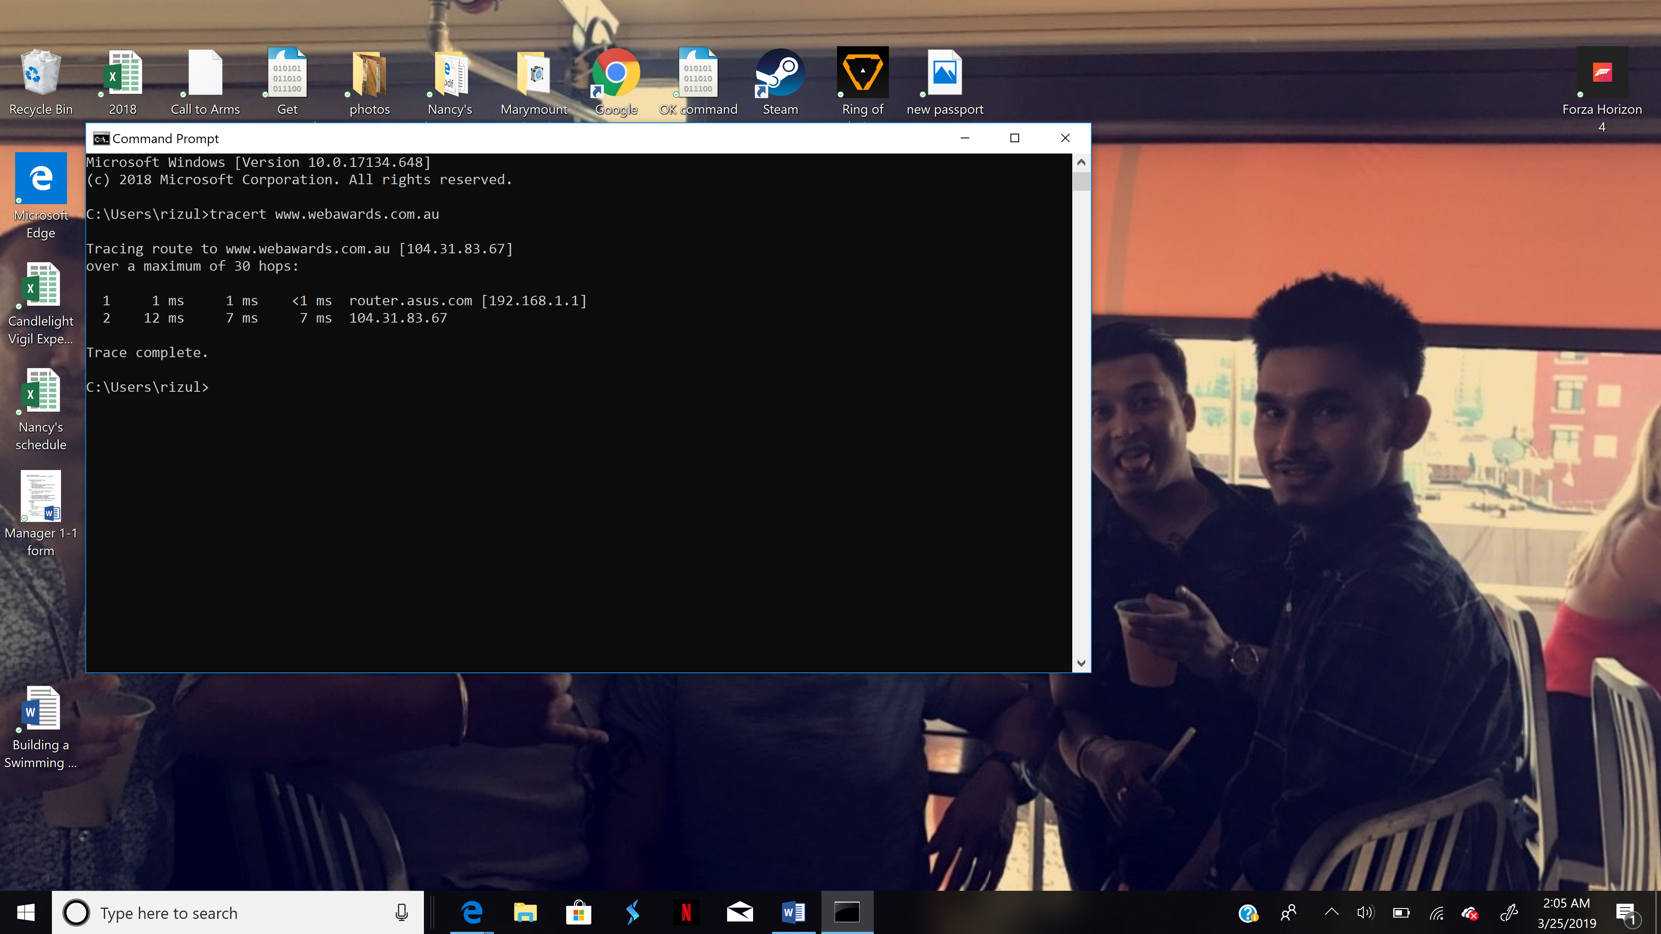

1. What is your computers IP address? (This is not included in your traceroute results). Take a screenshot of your computers IP address.

**192.168.1.71**

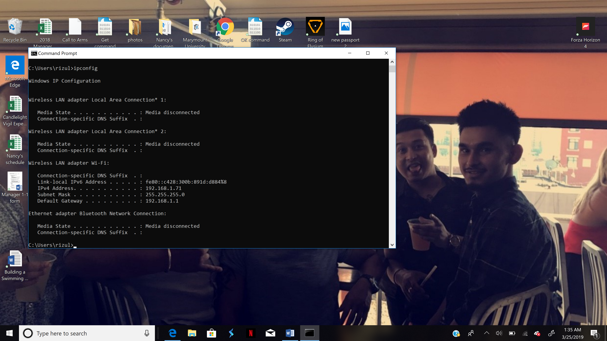



2. With reference to private/public IP addresses. What type of IP address is the first IP from your traceroute result.



**Private IP address**

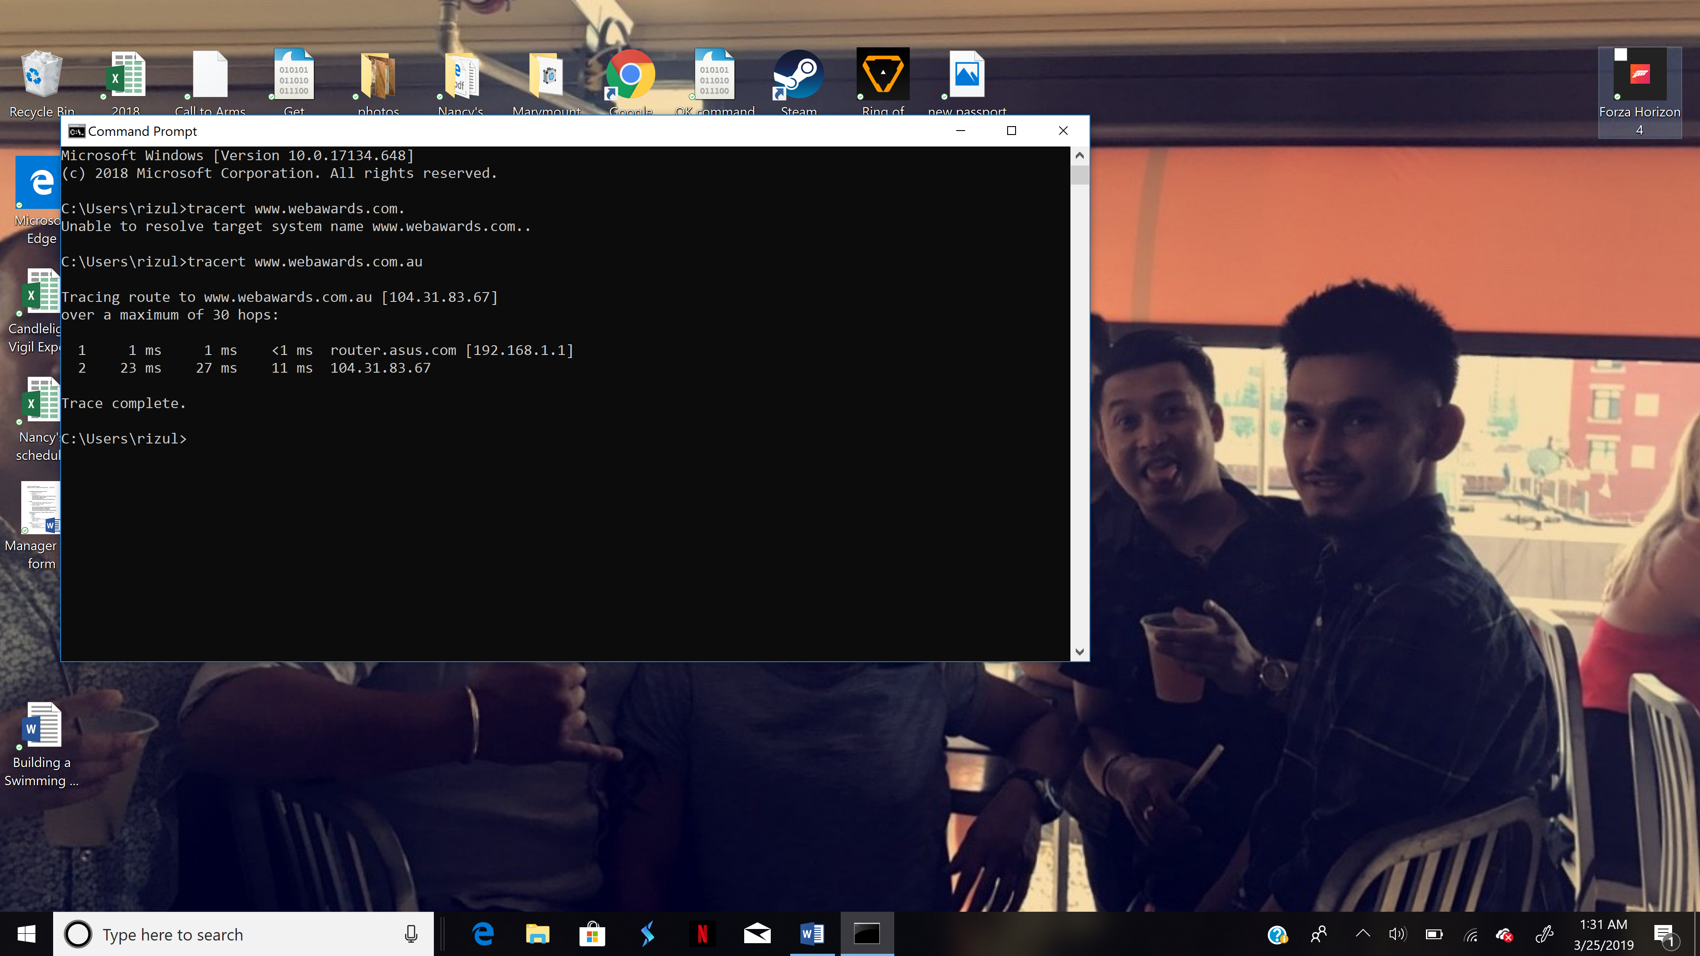



1. With reference to private/public IP addresses. What type of IP address is the second IP from your traceroute result.

**Public IP address**





1. In a tabular format (use table example below), and in sequential order. Indicate the location of each IP address (include state for US states) and the organization that owns the IP address. (Use https://www.ultratools.com/tools/ipWhoisLookup to look up IP address whois information).

|  |  |  |  |
| --- | --- | --- | --- |
| **Hop Count** | **IP address** | **Organization (IP Owner)** | **Location (US state)/Country** |
| **1** | **192.168.1.1** | **IANA** | **Los Angeles CA / USA** |
| **2** | **104.31.83.67** | **Cloudfare, Inc.** | **San Francisco, CA / USA** |

5. In your own words, explain everything you just did, and what route did your packet took from source to destination. How many US states did your packet go through? How many countries if any?

**I traced a packet from my device to** [**www.webawards.com.au**](http://www.webawards.com.au) **to see the route and the packet went through Los Angeles as a source and reached to its destination to San Francisco. So, the packet went through two different cities (Los Angeles and San Francisco) from California in the United States of America.**